**Name:** Mina Farid Shawky

**B.N:** 973

**Edu mail:**mina196096@feng.bu.edu.eg

**Topic:** Artificial intelligence

**GitHub link:**

**GitHub page:**

**Application brief:**

Artificial intelligence (AI) is wide-ranging branch of computer science concerned with building smart machines capable of performing tasks that typically require human intelligence. AI is an interdisciplinary science with multiple approaches, but advancements in machine learning and deep learning are creating a paradigm shift in virtually every sector of the tech industry.

**Screenshots:**

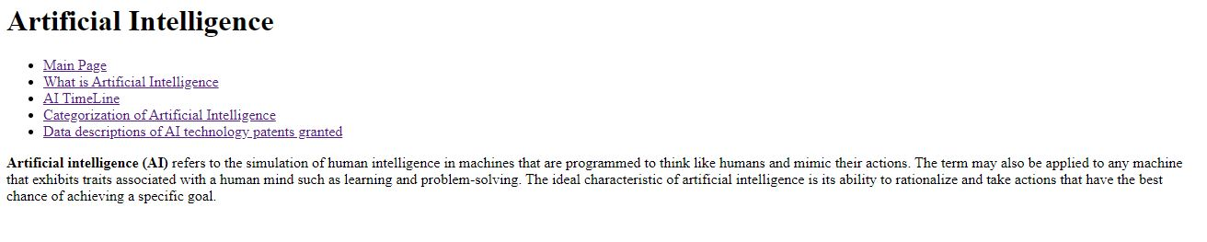 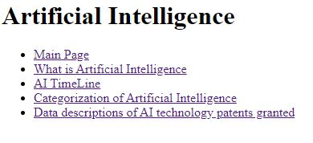

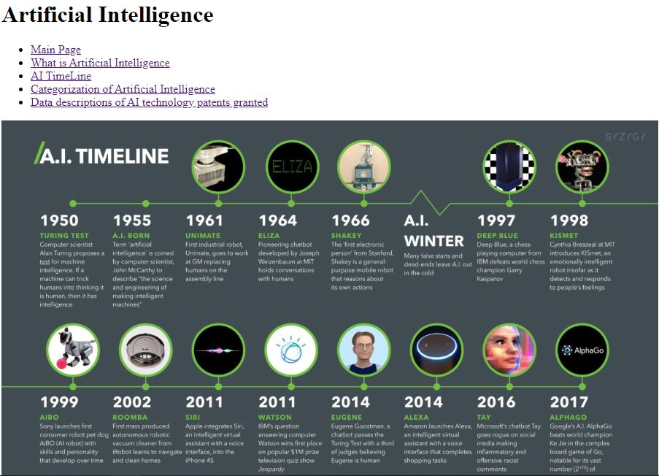

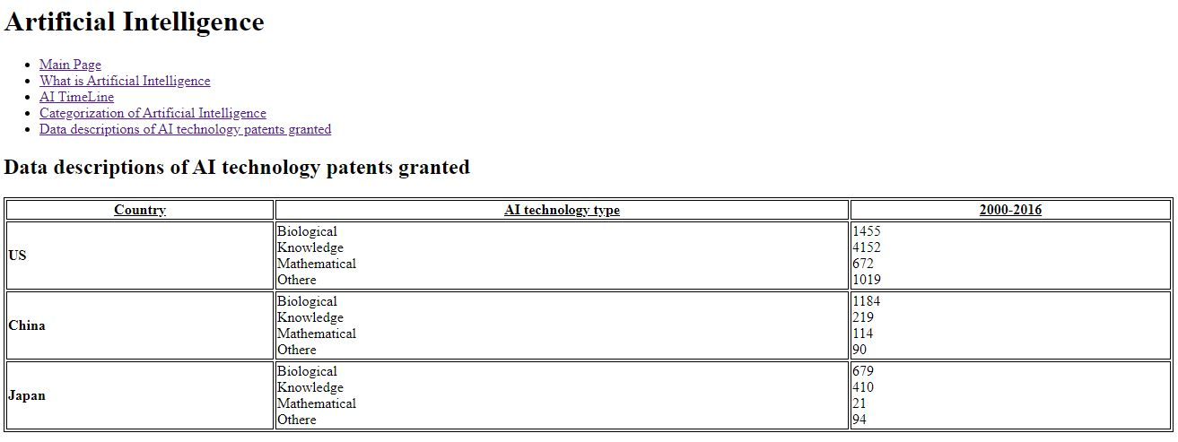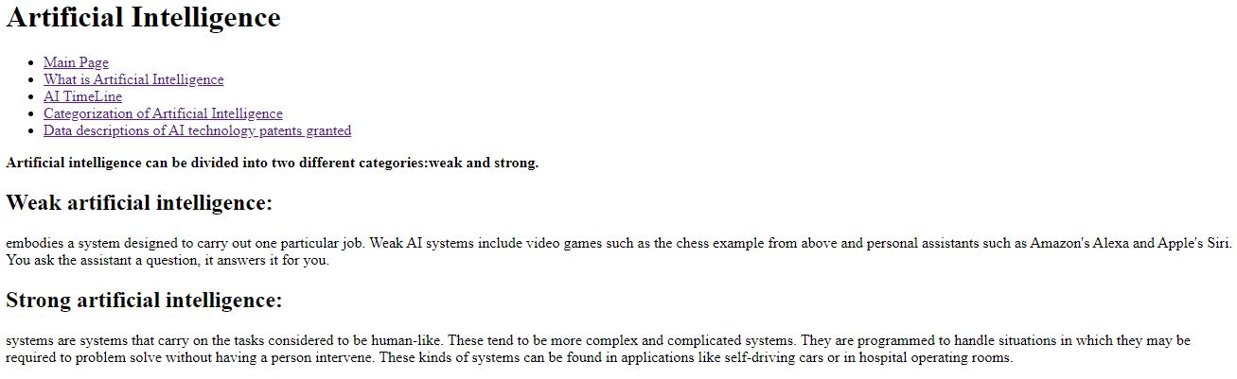

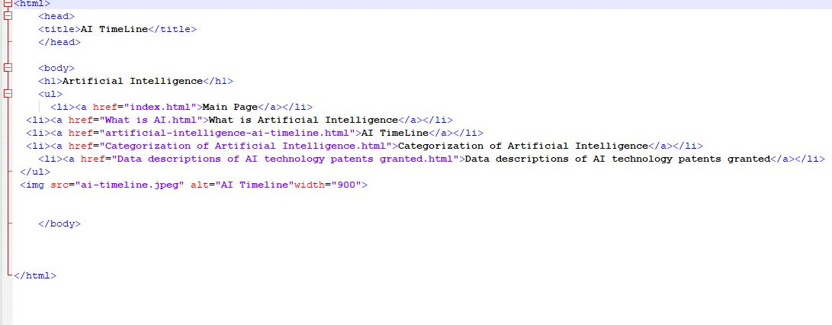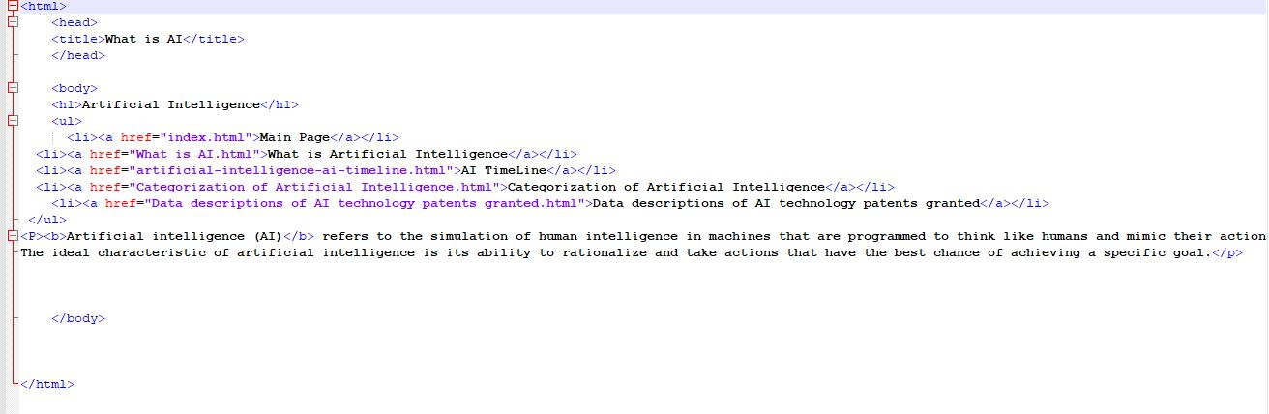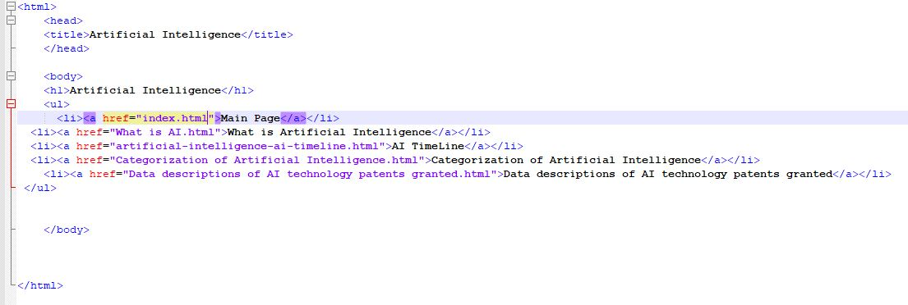**Source code:**

